Checkpoint 1

$$p_{xy}=\left[\begin{matrix}1 & 0 & 0 \\ 0 & \cos\left(\frac{π}{4}\right) & -\sin\left(\frac{π}{4}\right) \\ 0 & \sin\left(\frac{π}{4}\right) & \cos\left(\frac{π}{4}\right)\end{matrix}\right]\left[\begin{matrix}\cos\left(\frac{π}{4}\right) & 0 & \sin\left(\frac{π}{4}\right) \\ 0 & 1 & 0 \\ -\sin\left(\frac{π}{4}\right) & 0 & \cos\left(\frac{π}{4}\right)\end{matrix}\right]=\left[\begin{matrix}\cos\left(\frac{π}{4}\right) & 0 & \sin\left(\frac{π}{4}\right) \\ \frac{1}{2} & \cos\left(\frac{π}{4}\right) & -\frac{1}{2} \\ -\frac{1}{2} & \sin\left(\frac{π}{4}\right) & \frac{1}{2}\end{matrix}\right]$$

Checkpoint 2

$$p_{yx}=\left[\begin{matrix}\cos\left(\frac{π}{4}\right) & 0 & \sin\left(\frac{π}{4}\right) \\ 0 & 1 & 0 \\ -\sin\left(\frac{π}{4}\right) & 0 & \cos\left(\frac{π}{4}\right)\end{matrix}\right]\left[\begin{matrix}1 & 0 & 0 \\ 0 & \cos\left(\frac{π}{4}\right) & -\sin\left(\frac{π}{4}\right) \\ 0 & \sin\left(\frac{π}{4}\right) & \cos\left(\frac{π}{4}\right)\end{matrix}\right]=\left[\begin{matrix}\cos\left(\frac{π}{4}\right) & \frac{1}{2} & \frac{1}{2} \\ 0 & \cos\left(\frac{π}{4}\right) & -\sin\left(\frac{π}{4}\right) \\ -\sin\left(\frac{π}{4}\right) & \frac{1}{2} & \frac{1}{2}\end{matrix}\right]$$

Checkpoint 3: write down $t_{1}world cube$

$$\left[\begin{aligned}2 \\ -1 \\ 1\end{aligned}\right]+\left[\begin{aligned}1 \\ 1 \\ 2\end{aligned}\right]=\left[\begin{aligned}3 \\ 0 \\ 3\end{aligned}\right]$$

Checkpoint 4: write down $t_{2}world cube$

$$\left[\begin{matrix}1 & 0 & 0 & 2 \\ 0 & 1 & 0 & -1 \\ 0 & 0 & 1 & 1 \\ 0 & 0 & 0 & 1\end{matrix}\right]*\left[\begin{matrix}1 & 0 & 0 & 1 \\ 0 & \frac{\sqrt{2}}{2} & -\frac{\sqrt{2}}{2} & 1 \\ 0 & \frac{\sqrt{2}}{2} & \frac{\sqrt{2}}{2} & 2 \\ 0 & 0 & 0 & 1\end{matrix}\right]=\left[\begin{matrix}1 & 0 & 0 & 3 \\ 0 & \frac{\sqrt{2}}{2} & -\frac{\sqrt{2}}{2} & 0 \\ 0 & \frac{\sqrt{2}}{2} & \frac{\sqrt{2}}{2} & 2 \\ 0 & 0 & 0 & 1\end{matrix}\right]$$

Checkpoint 5:

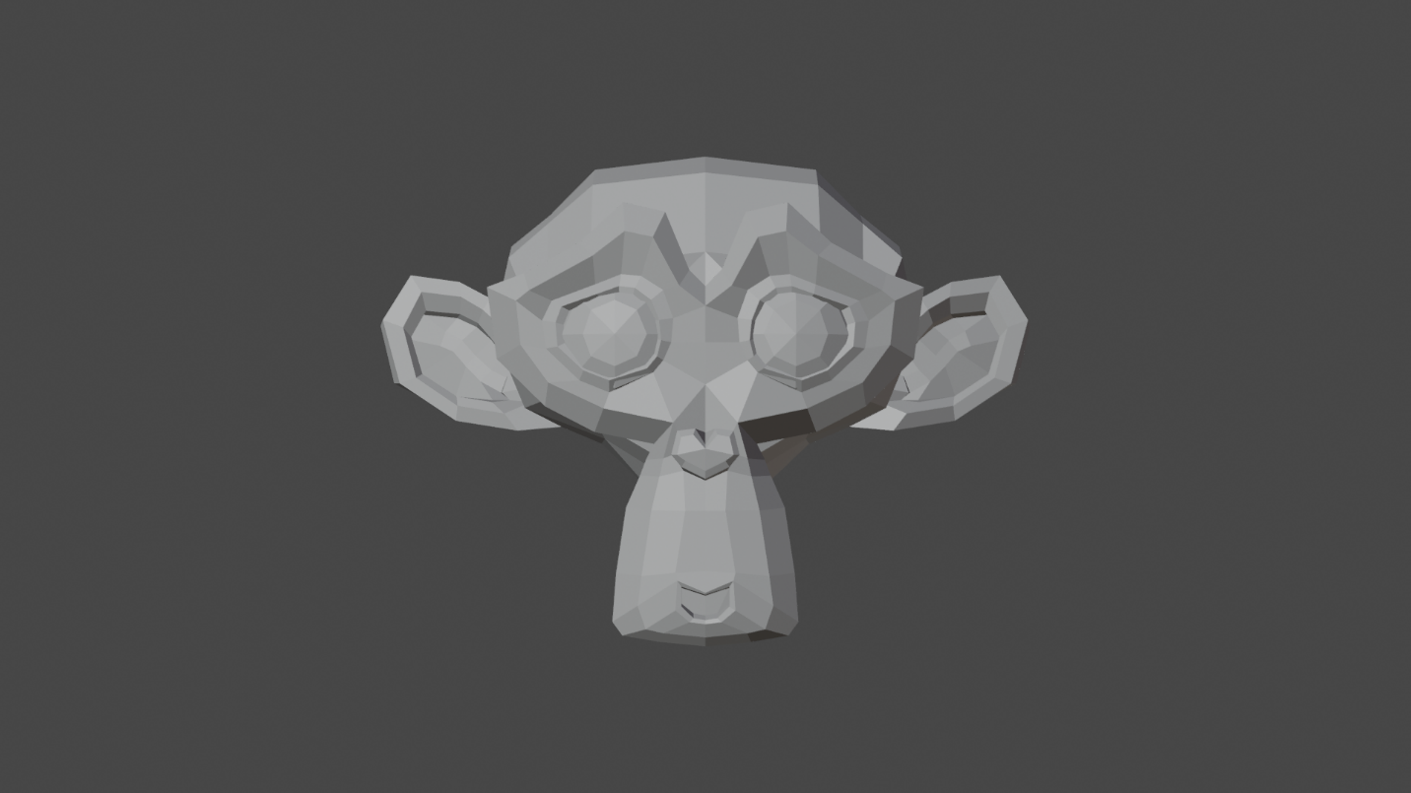





Checkpoint 6: they all look the same

